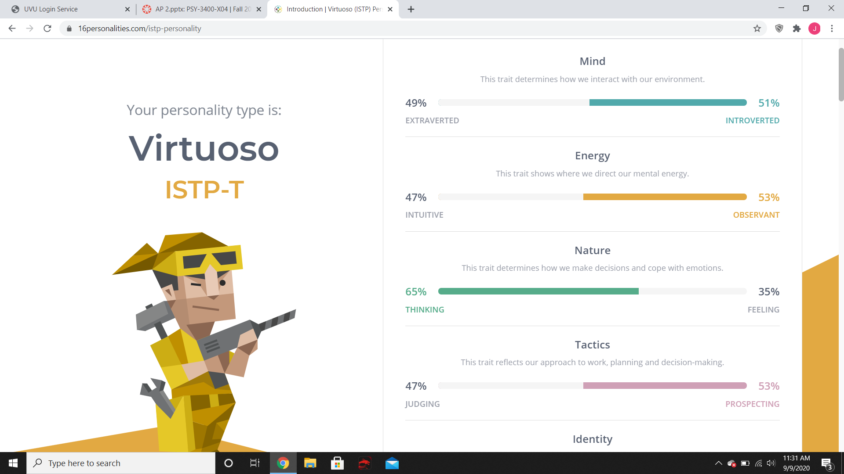

The test that I took made me feel like the assessment process is meant to make me look deeper inside of myself. I really had to think about questions that I had not given much though to before. However, I feel like I might have been biased about some things and so unless someone was there to look for other clues the assessment could be slightly off.